LEARNING OBJECTIVES

* Explain the components of an LCD system
* Describe the process for making LCD glass
* Illustrate a typical glassy structure
* Define a liquid crystal
* Discuss the applications of liquid crystal displays

INPUT PORTS

‘MyData’ with a value of 20.

OUTPUT PORTS

The code continuously updates an LCD display with various strings:

1. "ES TRAINING" on the first line.
2. "GITAM UNIVERSITY, BANGLORE" on the second line.
3. "CLASS STRENGTH XX STUDENTS" where XX represents the value of ‘MyData’ which is initially set to 20.

LOGIC

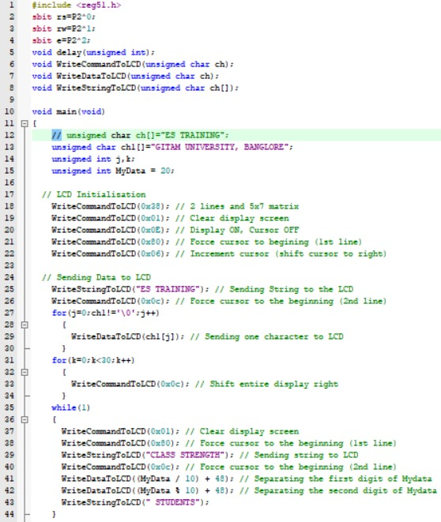

RESULT

The code initializes and continuously updates an LCD display:

* First line: "ES TRAINING"
* Second line: "GITAM UNIVERSITY, BANGLORE"
* Third line: "CLASS STRENGTH 20 STUDENTS" The number "20" is constant, representing MyData.